# **Album Eletiva IV**

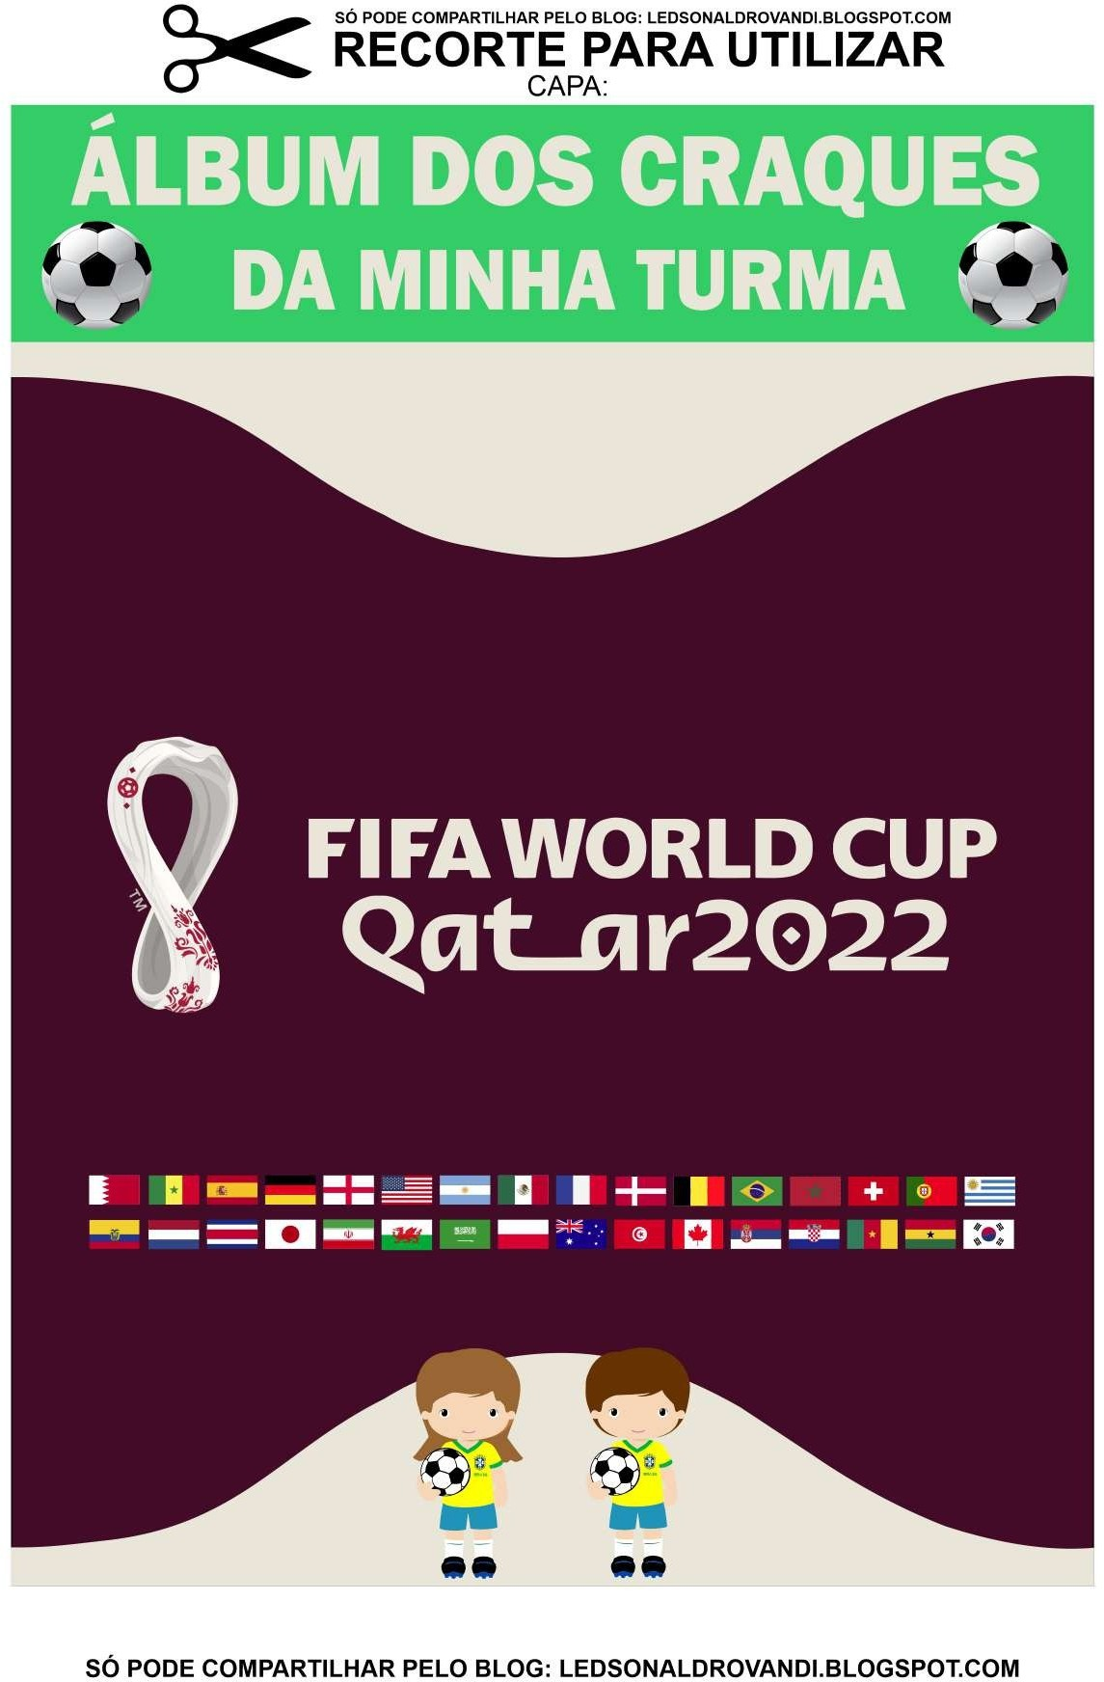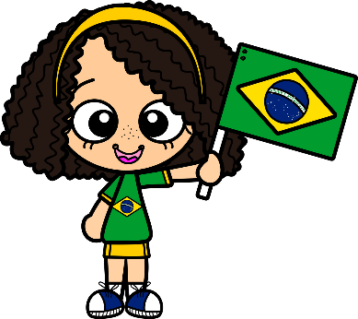

# **Vivendo e Aprendendo**

# **Com a copa**

## Craques da turma



|  |  |  |  |  |  |  |  |
| --- | --- | --- | --- | --- | --- | --- | --- |
|  |  |  | | | | | |
|  | Izabella |  | Wendel Victor |  | Maria Clara |  |
|  |  | | | | | |
|  | José Miguel |  | Thiago H |  | Eduardo L |  |
|  |  | | | | | |
|  | | Valentina |  | Kemily |  | Sthephany |  |
|  |  |  | | | | | |

**Craques da turma**



|  |  |  |  |  |  |  |  |
| --- | --- | --- | --- | --- | --- | --- | --- |
|  |  |  | | | | | |
|  | Lívia |  | Gleydeston |  | Emili |  |
|  |  | | | | | |
|  | Davi |  | José O |  | Eduardo Corrêa |  |
|  |  | | | | | |
|  | | João G |  | Artur |  | Vitor G |  |
|  |  |  | | | | | |

## Craques da turma



|  |  |  |  |  |  |  |  |
| --- | --- | --- | --- | --- | --- | --- | --- |
|  |  |  | | | | | |
|  | Pedro H |  | Raissa |  | Catriel |  |
|  |  | | | | | |
|  | Isadora |  | Ana Maria |  | Isaak |  |
|  |  | | | | | |
|  | | Cícero |  | Fabiano |  | Gabriel |  |
|  |  |  | | | | | |

# Craque da minha turma

